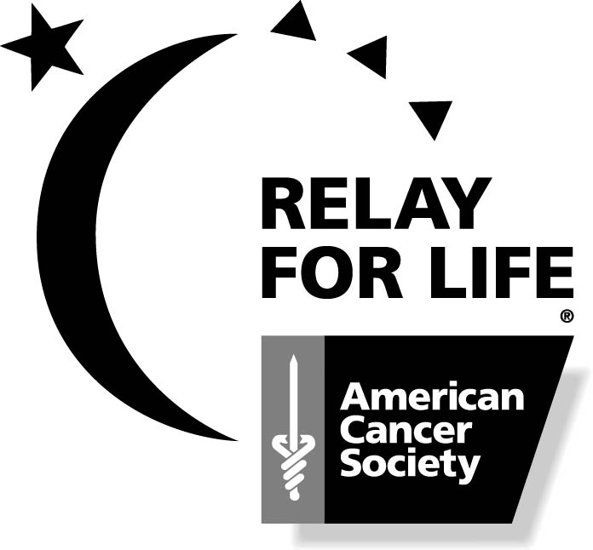
Relay For Life of Roanoke Valley

Corporate Sponsorship Agreement

________________________________________________________________________
(Sponsor Name as you would like it to appear in print)

_____________________________________________
(Official Representative)

_____________________________________________
(Address-City, State, Zip)

______________________________________________
(Phone)

2008 Corporate Sponsorship Levels (select only one):
_____ $2,500 Diamond
_____ $2,000 Platinum
_____ $1,000 Gold
_____ $500 Silver
_____ $250 Bronze
______ In-Kind Sponsorship – please describe donation: ____________________
___________________________________________________________

Team Name: If are a NEW sponsor, and you want your sponsorship to be credited to a Relay For Life team’s total money raised, please print that team’s name (Choose only 1 team) ________________________________________________________________________

Please submit corporate sponsor agreement, logo, and payment to Judy Manning by May 13th.
Logos only have to be sent if logo benefits apply to your chosen sponsorship level.
Please make all checks payable to the American Cancer Society and remit to:

Judy Manning
900 Monroe St.
Roanoke Rapids, NC 27870

For more information about Corporate Sponsorships, please contact:

- Judy Manning: 537-5708
- James Leake: 537-4874
- Laura Wilder: 537-6912
- Harvey Taylor: 537-3254
- Marie Moss: 537-2766
- Doodle Smith: 537-8749

Relay For Life of Roanoke Valley

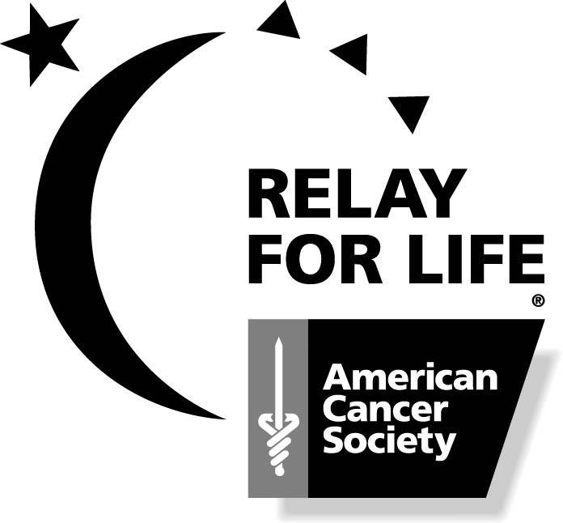
Corporate Sponsorship Opportunities

By being a sponsor you can help us continue the tradition of local charitable fundraising while contributing to the worthwhile mission of the American Cancer Society.

$2,500 Diamond Sponsor
- “Gold Post Light” advertising.
- Your company will be recognized during opening ceremony with the opportunity to speak.
- Preferred recognition on all printed flyers, and newsletters.
- Preferred recognition on all participant 1,000 plus T-shirts.
- Recognition in all interviews and personal promotions.
- Recognition in all press releases to local newspaper and radio.
- Publicity for 2,000 plus residents at event and location of choice in program.
- Complimentary entry fee and team sites for three teams (at 10 people per team).
- On-site signage at event for a total of three of your corporate banners.
- Sponsor may have a tent site to display goods, services, etc. Sponsor is responsible for own tent, fixtures, banners, etc.
- Up to ten announcements during the Relay For Life event.

$2,000 Platinum Sponsor
- Preferred recognition on all printed flyers, and newsletters.
- Preferred recognition on all participant 1,000 plus T-shirts.
- Recognition in all interviews and personal promotions.
- Recognition in all press releases to local newspaper and radio.
- Publicity for 2,000 plus residents at event and location of choice in program.
- Complimentary entry fee and team sites for two teams (at 10 people per team).
- On-site signage at event for a total of three of your corporate banners.
- Sponsor may have a tent site to display goods, services, etc. Sponsor is responsible for own tent, fixtures, banners, etc.
- Up to five announcements during the Relay For Life event.

$1,000 Gold Sponsor
- Recognition in advertising flyers and newsletters.
- Logo identification on participant T-shirts (1,000 plus).
- Recognition in interviews, personal promotions, and press releases.
- On-site signage at event for a total of two of your corporate banners.
- Publicity for 2,000 plus residents at event and prime location in program.
- Complimentary entry fee and team site for one team (at 10 people per team).
- Sponsor may have a tent site to display goods, services, etc. Sponsor is responsible for own tent, fixtures, banners, etc.
- Up to three announcements during the Relay For Life event.

Relay For Life of Roanoke Valley

Corporate Sponsorship Opportunities

By being a sponsor you can help us continue the tradition of local charitable fundraising while contributing to the worthwhile mission of the American Cancer Society.

$500 Silver Sponsor
- Recognition in press releases.
- Company name on t-shirts and newsletters.
- On-site signage at event for a total of one of your corporate banners.
- Publicity for 2,000 plus residents at event and location in program.
- Sponsor may have a tent site to display goods, services, etc. Sponsor is responsible for own tent, fixtures, banners, etc.

$250 Bronze Sponsor
- Publicity for 2,000 plus residents at event and location in program and press releases.
- Company name on t-shirts and newsletters.
- Sponsor may have a tent site to display goods, services, etc. Sponsor is responsible for own tent, fixtures, banners, etc.

Miscellaneous In-Kind Donations
- Other donations such as goody items, door prizes, food and beverage are also graciously accepted as in-kind items to thank the event participants.
- Publicity for 2,000 plus residents at event and location in program.
- Recognition in press releases.
- Formal recognition of sponsorship at event.
- One of your corporate sponsor banners displayed at event.

PLEASE SEND SIGNED CORPORATE SPONSOR AGREEMENT, LOGO, & MONEY TO:

Judy Manning
900 Monroe St.
Roanoke Rapids, NC 27870
537-5708

*SPONSORSHIPS ARE TAX DEDUCTIBLE.*

