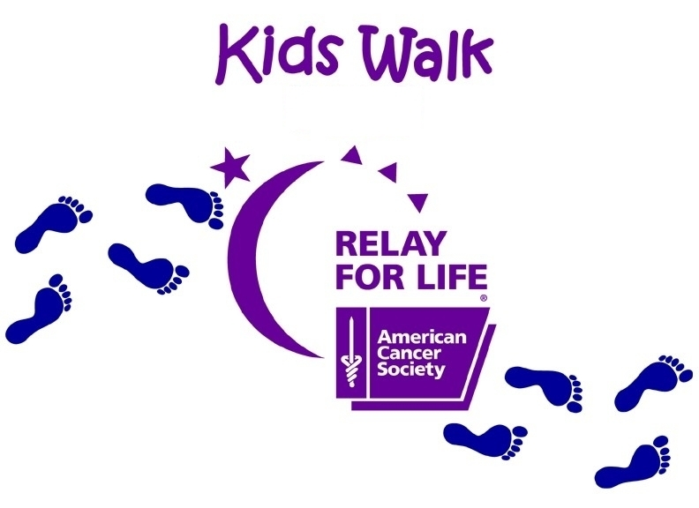
Relay For Life of Roanoke Valley
Kids Walk

Manning Elementary School Track
Saturday, June 21, 2008
10:00 am – 12:00 pm
What is Kids Walk?
The Kids Walk is a fun filled celebration designed for young people up to age 15 to participate and get involved in Relay for Life. The children are invited to walk around the track and enjoy a number of activities and games held during this 2-hour event.

How to Register:
Each child should complete the registration form below, pay a $10 registration fee, and try to raise $25. The registration deadline is May 13th, if kids are to be guaranteed a t-shirt. Kids can register until June 21st, but they may not receive a t-shirt.

The male and female who raise the most money will be crowned Little Mr. and Little Miss Relay. To be eligible, all money must be turned in to Tina Barnes by June 10th. Money can be mailed to Tina (address below) or money can be turned in to Tina on June 10th at 6:30 pm at New Life Church of Christ. If a child is not participating in the Little Mr. and Little Miss contest, money raised can be turned in at the Relay.

For more information, please contact Tina Barnes at 252-578-5202
------------------------------------------------------------------------------------------------------------------------------
Child’s Name: __________________________________________________________________________________
School Name:___________________________________________________________________________________
Parent or Guardian’s Name: _______________________________________________________________________
E-mail Address: ________________________________________________________________________________
Address: ______________________________________________________________________________________
City: ________________________________________ | Zip:_________________________________________
Phone: ________________________________________ | Age of Participant (up to 15) ___________________
Survivor (circle) Yes or No T-Shirt Size (circle): | YXS | YS | YM | YL |  | S | M | L | XL
In consideration of allowing my child to participate in the Relay for Life’s Kids Walk, I hereby assume any and all risks which might be associated with the event for myself, my child and our representatives, successors and assigns. I further waive, release, discharge and covenant not to sue either the American Cancer Society or Manning Elementary School, their management, officers, directors, members, sponsors, organizers, representatives and their successors and assigns for any injuries or damages of any kind whatsoever suffered as a result of taking part in the event and any related activities.
Parent/Guardian Signature: _______________________________________________ |  |  |  |  | Date: ________________

Please return completed registration form by May 13th to:

****Tina Barnes, 24 Arbor Dr., Roanoke Rapids, NC 27870****

Kids Making A Difference In The Fight Against Cancer

