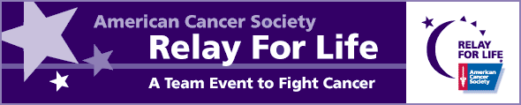

Dear Community Leader,

We would like to invite you and your company to become a corporate sponsor of the Roanoke Valley’s premier cancer awareness event – Relay For Life of Roanoke Valley. Relay For Life is a community celebration honoring cancer survivors and those touched by cancer.

Relay For Life of Roanoke Valley will be held June 20 & 21, 2008 at Manning Elementary School in Roanoke Rapids. Prior to the Relay event in June, teams of people participate in Relay For Life by sponsoring various fundraising events to raise money to help fight cancer. At the Relay For Life event on June 20 & 21, teams take turns walking around the track. Food is served and entertainment is provided. Come be a part of this family event to help fight cancer.

The money that is raised by volunteers and corporate sponsors for Relay For Life goes toward eliminating cancer in four main ways: research, education, advocacy, and service.

- RESEARCH: In 2007, your contributions helped fund over $15 million in cancer research in North Carolina including:
$9.5 million in cancer research at University of North Carolina
$3.6 million in cancer research at Duke University Medical Center
$1.1 million in cancer research at Wake Forest University
$720,000 in cancer research at Bowman Gray School of Medicine
- EDUCATION: The American Cancer Society has a wealth of health care information. W aim to prevent cancer through healthy living and early detection, so our information is not limited to information about cancer. The American Cancer Society is willing to share this information with anyone. Call 1.800.ACS.2345 or visit www.cancer.org for educational materials.
- ADVOCACY: The American Cancer Society works in the legislative arena to enact laws that benefit the public’s health.
- SERVICE: In the Roanoke Valley, your contributions help fund a program called Reach to Recovery, which allows newly diagnosed breast cancer patients to speak with breast cancer survivors about the cancer journey. Your contributions also help fund a smoking cessation program at Halifax Regional Medical Center.

Cancer touches everyone. Please help us eliminate this disease by becoming a corporate sponsor for Relay For Life of Roanoke Valley. We need you. Enclosed is a sponsorship packet for your review. If you have any questions, please contact anyone on the Corporate Sponsor Agreement.

Thank you for your consideration,

2008 Relay For Life Sponsorship Committee

