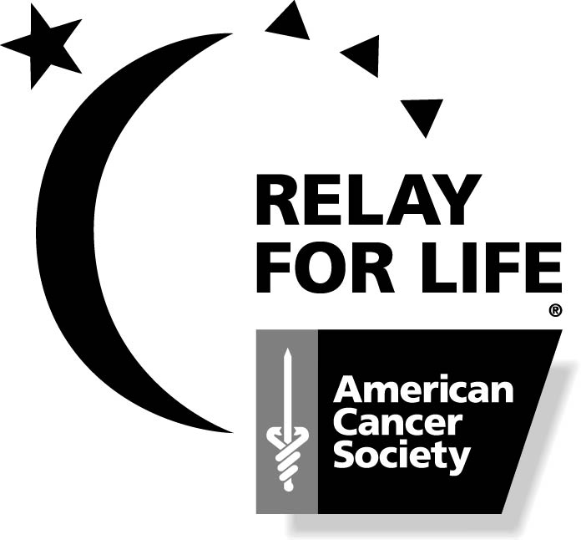
Survivor Registration Form
Roanoke Valley Relay For Life

“A Celebration of Life”

The Survivor’s Dinner will be held on Friday, June 13, 2008 at 6:00 p.m. at

Kirkwood Adams Center

The Survivor’s Lap will take place on Friday, June 20, 2008 at 6:00 p.m. on the
Manning Elementary School Track
* Please report to Survivor Tent at 5:30 to register and prepare for Survivor Lap *

Please complete this form and return to:
Virginia Gupton, 1204 Hamilton St., Roanoke Rapids, NC 27870

Name_________________________________________________________
Address_______________________________________________________
City__________________________________________________________ State_______________________________ Zip______________________
Home Phone______________________ Work Phone____________________
E-mail________________________________________________________

Participation in 2008 Relay Activities—Please supply information needed for planning:

- Do you plan to attend the Survivor’s Dinner on June 13? Yes____ No____

- Do you plan to bring a guest to the Survivor’s Dinner? Yes____ No____

- Do you plan to walk the Survivor’s Lap on June 20? Yes____ No____

- Check T-Shirt size: YM___S___ M___ L___ XL___ XXL___ XXXL___

- May we include your name in the list of Survivors to be read at the Relay Opening Ceremony? Yes____ No____

- Type of Cancer_______________________ Year First Diagnosed______

- Are you between the ages of 3 and 18? Yes____ No____

VOLUNTEER OPPORTUNITIES:
Please check any of the following if you would like to be contacted about volunteering.

Relay For Life:
___ Be involved with a team
___ Be on the planning committee
___ Participate in the survivor lap

Advocacy:
___ Be a part of the Action Network

Patient Service Programs:
___ Reach to Recovery Program
___ Road to Recovery Program
___ Man to Man Prostate Support Group
___ Look Good…Feel Better Program
___ I Can Cope Program

Relay For Life
RELAY FOR LIFE is a one-of-a-kind, fun way to raise money for the American Cancer Society, celebrate survivorship, and inform our community about cancer prevention, early detection, and patient services. It is the American Cancer Society's nationwide signature overnight event, where teams organize and take laps around the track to symbolize the nonstop battle against cancer. Relay is a fundraising event, but is much more than that – it is a celebration of survivorship and a community fair with a purpose. There are activities, entertainment and lots of delicious food for children and adults. The funds raised at Relay For Life contribute to research as well as provide for local and national programs for cancer survivors and their families.

Patient Service Programs
I Can Cope is an education program about living with cancer. Sessions offer free classes led by health care providers, social workers and others qualified to share information with patients and family members about cancer and its treatment.

Man to Man is a program that offers “one on one” and group support to men facing prostate cancer.

Look Good…Feel Better teaches cancer patients techniques to address the cosmetic side effects of treatment.

Reach to Recovery is a program in which trained volunteer breast cancer survivors provide peer-to-peer support and information to others experiencing or concerned about breast cancer.

Road to Recovery is a program in which trained volunteers drive cancer patients to and from their treatment.

Advocacy
Action Network is…
- Lobbying to increase funding for cancer research and programs
- Lobbying to increase access to care for underserved populations
- Educating legislators on all tobacco-related issues

